План-конспект
открытого урока по английскому языку
по теме «Science and Industry Progress»
в группе П 31- 22; 09.02.03 Программирование в компьютерных системах - 3 курс.

Раздел: «Science and Technology»
Тема: «Science and Industry Progress»
Тип урока: Урок практической направленности
Форма урока: Практическое занятие
Цель урока: Изучить новый лексический материал по теме «Наука и технический прогресс. Интернет », развивать коммуникативную, языковую компетенцию.
Задачи урока:
Образовательные:
Познакомить с новыми лексическими единицами. Активизировать познавательную активность обучающихся.
Развивающие:
Способствовать развитию навыков монологической и диалогической речи с использованием опорного материала. Развивать навыки детального понимания содержания диалога с извлечением конкретной информации. Формировать умение анализировать и обобщать учебный материал.
Воспитательные:
Воспитание культуры общения, формирование ценностных ориентаций, формирование здоровых привычек и развитие кругозора.
Оснащение:
- Английский язык для технических специальностей = English for Technical Colleges : учебник для студ. учреждений сред. проф. образования / А. П. Голубев, А. П. Коржавый, И. Б. Смирнова. — 4-e изд., стер. — М. : Издательский центр «Академия», 2014. — 208 с.
- мультимедийный проектор
- экран
- карточки со словами ( раздаточный материал)

Методы и методические приёмы:
• словесный (беседа, рассказ);
• наглядный (метод демонстраций);
• практический (письменные и устные упражнения).

Межпредметные связи: информатика, русский язык, социальная психология.
Аспекты языка: лексика, грамматика.
Виды речевой деятельности: говорение, чтение, аудирование.
Режим работы: индивидуальный, групповой.
Виды упражнений: языковые, условно речевые.
Технологии: Дифференцированный подход к учащимся, интенсификация обучения на основе схем и опорных конспектов, компьютерные технологии.
Используемая методическая литература:
- Английский язык для технических специальностей = English for Technical Colleges : учебник для студ. учреждений сред. проф. образования / А. П. Голубев, А. П. Коржавый, И. Б. Смирнова. — 4-e изд., стер. — М. : Издательский центр «Академия», 2014. — 208 с.

The procedure of the lesson:

I.Organization moment:

1.Greeting. Good morning? Glad to see you! How are you?

2.:
Check up the educational accessories.
What date is it? Who is absent today? What problem has he (she)? Are you ready for the lesson? Let’s start!

3.Creation the language atmosphere
What is the weather like today? What season is it now? Is it raining today?

II. Brainstorming

a)Game “ Find the words”
Camera- 3 1 13 5 18 1 Mobile phone- 13 15 2 9 12 5 16 815 14 5 Microwave- 13 9 3 18 15 23 1 22 5 Fridge- 6 18 9 4 7 5 Radio- 18 1 4 9 15 Computer- 3 15 13 16 21 20 5 18 Plane – 16 12 1 14 5
Vacuum cleaner- 22 1 3 21 21 13 3 12 5 14 5 18 Washing machine – 23 1 19 8 9 14 5 13 1 19 9 14 5

b) Think the theme of the lesson. Use the first letter of each words.

III. Warm –up.
T:We have learned many facts about useful inventions which were made in the long history of mankind. Most of them have really brought us comfort and convenience. We cannot imagine our life without electric lamps, cars or telephones, television or computers. They have changed the life of many people. We use modern inventions in our everyday life and they make it easier.

Can you guess what are we going to speak about at our lesson?
Right you are, the topic of our lesson today is « Scientific and technological progress or new technologies in our life».

What do you associate with the word TECHNOLOGIES? 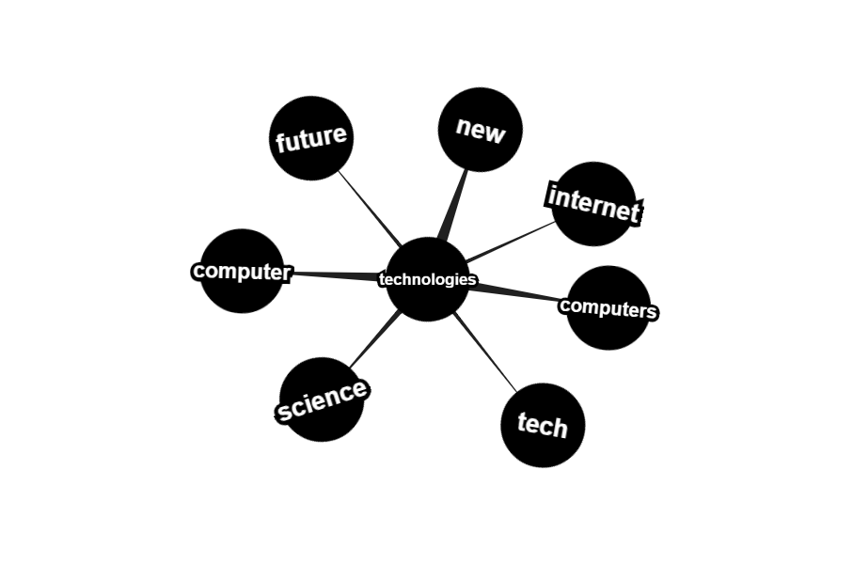

Problem questions:
What are gadgets, computer, Internet, TV, radio?
What are they for? What do you use a camera for? Etc.
Why do we need them?
К концу урока мы ответим на эти вопросы.

IV. New material

a)Read the words with the translations. Pay your attention to the pronunciation of the words.
huge[ huj:dӡ]- громадный
network[netwә:k]- сеть
database [ databeize]-база данных
e- mail1[ i: mail]-электронная почта
service- [ sә:vis]- служба
search-[ sә:tᶘ]- искать
search programme-[sә:tᶘ prɔgrᴂm]-поисковая программа
Inventions- Изобретения
antibiotics -антибиотики
automobile -автомобиль
battery- батарейка
eBook -литературное произведение в электронном формате (электронная книга)
eBook reader- устройство для чтения электронных книг
electronic money- электронные деньги
GPS technology- система спутниковой навигации
jet airliner -реактивный самолёт, лайнер
LED (light emitting diods)- светодиоды
mobile/cell (AmE) phone- мобильный телефон
МРЗ-player -трЗ-плеер
netbook- нетбук
printing press -книгопечатаный станок
social networking/media site- социальная сеть
steam engine- паровой двигатель
tablet PC/pad -планшетный компьютер, «таблетка»
telescope- телескоп
television- телевидение
text messages/SMS- CMC-сообщения
Walkman- кассетный плеер

b)Reading and speaking

1)Technological Progress
For centuries people have been inventing things to make life easier. Among the greatest inventions of the past are the automobile, the steam engine, the electricity, the telephone and television. Since the beginning of the 20th century people have made a huge step in technology. Now we live in flats, talk to people who live in other parts of the world, travel from one place to another by plane. All these things are a product of technological progress and it is still growing rapidly.
Today we live in the world of machines and computers. Every day more and more gadgets appear and all of them make our life easier. Some of the new inventions have become so affordable and common, that now people cannot imagine life without them. For example, the mobile phone has turned from an expensive portable phone into an inexpensive data, e-mail, and voice service that almost anyone can afford. At the speed that mobile phones are evolving they may one day replace in-home phone services. Years ago mobile phones were bulky and required large batteries in a carrying case. Today's mobiles fit in a pocket and can replace a computer.
Another example of modern high-tech inventions is the Internet. Almost every company in the world has its own website. The Internet provides any kind of information on any topic. Of course, some of the sources are not reliable, but the Internet gives a very good opportunity to shop, book rooms and flights, watch films, listen to music and many other things. The Internet also gives an opportunity to make new friends and find old ones thanks to social networking sites such as Facebook or Vkontakte.
Computer technology has influenced production processes and made work easier. Toy companies, for example, incorporate computer chips in toys which make them move, talk and sing on their own. The car industry has computer systems installed in cars and they give information on car's condition, including tire pressure, headlights or the temperature inside and outside. Printing has become much easier with the computer-based printing machines.
Tablet PCs are becoming more and more popular today. They are much lighter than notebooks or netbooks and they contain all the software that is needed for business, studies and pleasure. EBook readers are a new invention too. This is a very convenient gadget that allows uploading books in different electronic formats. Instead of carrying one paperback book in a bag, you can carry one eBook reader with thousands of books on it.
Surely, these new inventions are not the last ones that humanity has developed and many others will be developed year upon year.

2)Reading and speaking about the Internet.
The Internet is a huge network of computers. Public Internet began in the late 70’s. The Internet is very helpful, because it is a huge database of knowledge. Everyone should have the Internet as a means of communication. Besides data one can get from the Internet, we can also send and receive e- mail. This internet service is cheaper than ordinary mail and much quicker. It is becoming popular day by day. We can get some news from the Internet, because there are many informational services in the web. For this we can get use different search programmes such as the google search programme, rambler search programme, yandex search programme or yahoo search programme. They are very simple and popular networks of sites.

Answer the questions:

1. Why have people been inventing new things for many centuries?
2. What are the basic greatest inventions of the past?
3. What does the modern world look like?
4. How can you describe technological progress now?
5. What can you say about mobile phones as inventions?
6. Have you got a mobile phone?
7. Can you live without a mobile now? Why (not)?
8. Do you consider the Internet a great invention? Why (not)?
9. How often do you browse the Net?
10. What are your favourite sites?
11. Do you have an account on any of the social networking sites?
12. Have you got a tablet PC? Would you like to have it and why?
13. Do you think that eBook readers are a great invention?
14. Do you use such a reader?
15. Do you think that eBooks will replace paperback books in the future? Why (not)?
16. What other inventions do you know? What can you tell about them?
17.What is the Internet?
18.When did public Internet appear?
19.In what way can the Internet be useful to everyone?
20.What can you say about advantages of the e- mail?
21.What search programmes do you know? Which one do you use?

V. Group work.
Read the text and give the correct answers

What are computers?
A computer is a programmable machine. Computer's parts are a system block, a monitor, a display, a keyboard, a mouse, a disk drive, a modem, a printer, a scanner.
The major parts of a PC include the motherboard, central processor unit, memory, hard drive and video card.
Hardware is the computer equipment. Each hardware device has a diver, like video card drivers, or modem drivers. They need to be installed.
Drivers are mini programs or instructions that tell your computer how to use its hardware. The most important program that runs on a computer is the operating system.
You have a network when two or more computers are connected to each other. We have a network in our computer classroom.
Software is a number of computer programs. Computer programs are large lists of instructions for the computers.

- Who can answer the questions quicker and give the correct answers?
1.What is a programmable machine? a computer
2.What is the computer equipment? hardware
3.What are mini programs or instructions that tell your computer how to use its hardware? drivers
4.What is the most important program that runs on a computer? the operating system
5.What do we have when two or more computers are connected to each others?
a network
6.What is a number of computer programs? software
7.What are large lists of instructions for the computers? the computer programs
8.Who is a person who secretly gets into another person's computer system? a hacker
9.What is a computer program that infects the computer memory or hard disk? a virus
10.What is a global computer network? the Internet
11.How do we call a company that sells computer access to the Internet? a provider

VI.Practice

TASK 1. Who will be the quickest? Match the words with their translation
1.personal computer (PC)
2.system block
3.monitor
4.display
5.screen
6.keyboard
7.mouse
8.mouse pad
9.hard drive
10.hardware
11.drivers
12.motherboard
13.central processor unit
14.memory
15.video card
16.disk drive
17.printer
18.scanner
19.device
20.network
21.connect
22.operating system
23.instruction
24.install
25. software
26.equipment

a)устройство
b)монитор
c)дисплей
d)сеть
e)nepсональный компьютер
f) блок
g)жесткий диск / винчестер
h)коврик для мышки

i)cканер
j)загружать
k)клавиатура
l)детали компьютера
m)драйверa
n)дисковод
o)видеокарта
p)npинтep
q)память

r)мышка
s)onepaционная система
t)материнская плата
u)экран
v)o6орудование
w)центральный процессор
h)соединять
y)инструкция
z)nporpаммное обеспечение

VII. Please act out the dialogue.Совершенствование навыков говорения.

T. And now let us listen to the dialogue between two students about gadgets.
Jane: Can you explain me what gadget is?
Tom: Technically, gadget is a small device or machine with a particular purpose: for example, a juicer, a blender, a coffee grinder, etc. They make our life easier and bring us convenience.
Jane: Well, what about a computer or a laptop? Are they also gadgets?
Tom: I think they are. A computer or a laptop are programmable machines, which include the monitor, keyboard, and a mouse (or a touchpad).
Jane: What can you tell me about the Internet?
Tom: The Internet isn`t gadget. The Internet is a gigantic web of computers that connects people across the globe. Providing an easy access to information and entertainment. The internet has become an everyday tool for everyone to use. Tell me, how often do you use the Internet?
Jane: Rather often, I'd say. I use it every day, because I need to read the news, to listen to music, to chat with friends.
Tom: Do you have any other questions?
Jane: Yes, few more questions. What gadget is the most popular among teenagers nowadays?
Can you tell me what your favourite gadget is?
Tom: I think that nowadays the most popular gadget is a personal computer. Nearly everyone is addicted to his mobile phone. All people have computers or laptops in their houses and they definitely use the Internet every day.
Jane: I see. Thanks for helping me.

Group work.
Вовлечение учащихся всей группы в обсуждение темы, заявленной в диалоге. Прием «Карусель»: учащиеся (по кругу) задают друг другу вопросы и отвечают на них, высказывая свою точку зрения.

T. Thank you. Now in groups discuss the topic and try to answer the questions
What are gadgets?
What are they for?
Why do we need them? - Students are verbalizing their thoughts.

VIII. Reflection «Рефлексия»

T.: Let`s summarize our lesson.

What modern inventions do people use?
What is the definition of gadget?
What are they used for?
What can you say about various devices?
Do you use your computer only for playing games?
Do you believe that technology has had the positive/negative affects?
What is your opinion?

IX. Conclusion T-S,S.. Estimating the activity
Teacher: What new information have you learned at the lesson?
What did you like the most?
What difficulties did you have?
Did you like the lesson?

Who was the TOP student today? – кто был лучшим сегодня, по вашему мнению?(Учащиеся оценивают свою работу на уроке).

Feedback - обратная связь
What was new for you?
What was the most interesting to you?
What could be improved?
Who was the TOP student today?

Write down your homework, please: You should write short composition about
the most popular modern technologies among our group are …
Teacher: I want you to say that you are brilliant. You all get excellent marks today.
You have worked very hard.

