МИНИСТЕРСТВО ОБРАЗОВАНИЯ, НАУКИ И МОЛОДЕЖНОЙ ПОЛИТИКИ КРАСНОДАРСКОГО КРАЯ
«Новороссийский колледж строительства и экономики»
Краснодарского края
(ГАПОУ КК «НКСЭ»)

Методическая разработка
по дисциплине «Иностранный язык»
для всех специальностей 1 курса
Преподаватель Вавилова Н.Ю.
Тема урока : «Экскурсии и путешествия»
Тип урока - комбинированный
Цель урока – Способствовать развитию коммуникативных и лексико-грамматических навыков по теме «Экскурсии и путешествия»
Задачи:
1.Обучающие
культуре общения,
умению понимать английскую речь.
2. Воспитательные
воспитание уважения к собеседнику,
умению работать в команде.
3. Развивающие
развитие логического мышления, воображения, памяти,
формирование мотивации к изучению английского языка.
4. Образовательные
тренировка в аудировании, говорении (диалогическая и монологическая речь),
активизация употребления страноведческой лексики в устной и письменной речи,
практика в оформлении группового проекта с использованием компьютерных технологий.

Средства обучения и оборудования
компьютер
мультимедийный проектор
аудиозапись

План урока:
1. Изучите лексический материал.
2. Для закрепления лексико-грамматического материала прочитайте и переведите текст «Tourism»
3.Ответьте на вопросы по тексту, используя тематическую лексику и фразы,
4.Опишите иллюстрации.

1. Active vocabulary:

overseas — заграница
majority — большинство
to seem — казаться
to book — заказывать
resorts— курорт
straight — прямо
a tropical beach — тропический пляж
to breathe — дышать
to hitclbhike — путешествовать автостопом
advantage — преимущество
to explore — исследовать
to climb — взбираться, карабкаться
restriction — ограничение
indeed — действительно
curious — любопытный
inquisitive — любознательный
leisure — досуг
jet-air liner — реактивный самолет
security — безопасность
variety — разнообразие
city-dweller — городской житель
to take pictures — фотографировать
castle — крепость, замок
waterfall — водопад
to remind — напоминать
picturesque — живописный
to broaden one's mind — расширить кругозор
take part in negotiations — принимать участие в переговорах
exhibition — выставка
in order to — для того чтобы
to push the goods — рекламировать товары
achievement — достижение
successful — успешный
advantages and disadvantages — преимущества и недостатки
according to — согласно
2. Read the text and answer the questions:
Tourism

Twenty years ago not many people travelled overseas for their holidays. The majority of people stayed to have holidays in their country. Today the situation is different and the world seems much smaller.
It is possible to book a holiday to a seaside resort on the other side of the world. Staying at home, you can book it through the Internet or by phone. The plane takes you straight there and within some hours of leaving your country, you can be on a tropical beach, breathing a super clean air and swimming in crystal warm water of tropical sea.
We can travel by car, by train or plane, if we have got a long distance tour. Some young people prefer walking or hitch-hike travelling, when you travel, paying nearly nothing. You get new friends, lots of fun and have no idea where you will be tomorrow. It has great advantages for the tourists, who want to get the most out of exploring the world and give more back to the people and places visited. If you like mountains, you could climb any mountains around the globe and there is only one restriction. It is money. If you like travelling, you have got to have some money, because it is not a cheap hobby indeed. The economy of some countries is mainly based on tourism industry. Modern tourism has become a highly developed industry, because any human being is curious and inquisitive, we like leisure, visit other places. That is why tourism prospers.
People travel from the very beginning of their civilization. Thousands years ago all people were nomads and collectors. They roamed all their lives looking for food and better life. This way human beings populated the whole planet Earth. So, travelling and visiting other places are the part of our consciousness. That is why tourism and travelling are so popular.
Nowadays tourism has become a highly developed business. There are trains, cars and air jet liners, buses, ships that provide us with comfortable and secure travelling.
If we travel for pleasure, by all means one would like to enjoy picturesque places they are passing through, one would like seeing the places of interest, enjoying the sightseeing of the cities, towns and countries.
Nowadays people travel not only for pleasure but also on business. People have to go to other countries for taking part in different negotiations, for signing some very important documents, for participating in different exhibitions, in order to exhibit the goods of own firm or company. Travelling on business helps people to get more information about achievements of other companies, which will help making own business more successful.
There are a lot of means of travelling: travelling by ship, by plane, by car, walking. It depends on a person to decide which means of travelling one would prefer.

3. Questions:

1. Did the majority of people leave their country to spend holidays twenty years ago?
2. Can we book a holiday to a seaside resort on the other side of the world today?
3. Is it possible to book a holiday to a seaside resort on the other side of the world from home?
4. What means of travelling do you know?
5. What countries depend mainly on tourism?
6. Why does tourism prosper?
7. Where do people like going on vacation?
8. What is the most interesting means of travelling for you? Why?
9. Why do most travellers carry a camera with them?
10. What does travelling give us?
11. How does travelling on business help you?
12. What are the means of travelling?

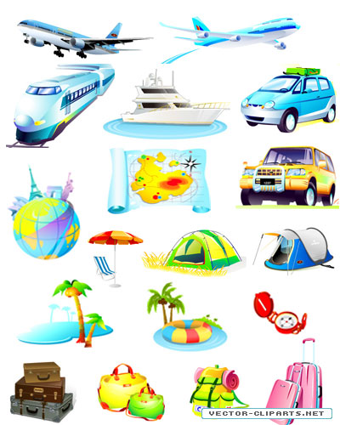
4. Describe the illustrations:

