Практическая работа №1

Раздел № 1 Вводно-корректирующий курс.
Тема: «Знакомство»
Цель: развитие лексико-грамматических навыков
Ход:
1. Изучите текстовый материал (ЭУМК, тема 1.1), выполните задание 1.
2. Устно переведите текст (ЭУМК, тема 1.1), ответьте письменно на вопросы на английском языке - задание 2.
3. Составьте рассказ о себе, заполнив пропуски – задание 3.
4. Изучите лексику из задания 4 и опишите себя, своего друга/подругу, сестру/брата в соответствии с образцом (Model).
1.Прочитайте текст, обращая внимание на формы глагола to be, to have, to do.
About Myself
Му name is Tanya Bobrova. I am 17.1 was born on the 5 of March 2005 in Moscow. My family is not very large. We have five people in our family. I live with my parents, my younger sister and my grandmother. My father’s name is Vladimir Ivanovich. He is forty years old. He is a doctor and he works at a hospital. My mother’s name is Lyudmila Leonidovna. She is thirty-nine years old. She is a housewife. My younger sister Natasha is a pupil. She is in the seventh form. My grandmother lives with us. She doesn’t work. She is a pensioner. I love my family. We are all friends and we love each other. We live in a big flat in a new house. There are four rooms in our flat: a living room, a study, two bedrooms, a kitchen, and a bathroom. We have all modem conveniences: gas, hot water, running water, electricity and telephone. I have my duties about the house. I must go shopping, clean the rooms. It’s not difficult for me. I want our home to be clean and tidy. I think there is no place better than home. Last year I finished school number 92. We had many well-educated teachers at our school. I was a good pupil and I did well in all subjects. My favourite subjects at school were Mathematics, Russian and English. Now I’m a first course student of the college. I have many friends. Most of them are my classmates. We spend much time together, go for a walk or to a disco party, talk about lessons, music, and discuss our problems. I like reading. I like detective stories but I prefer to read historical novels or modem writers. I like to listen to modem music, but sometimes I like to listen to some classical music. My favourite composer is Tchaikovsky. 1 haven’t much time to watch TV but sometimes I spend an hour . Му friends 21 or two watching an interesting film or a news programme. In the evening I often look through fresh newspapers or read some interesting book. I like fresh air and exercises, but I have not much time for doing sports.

Задание 2. Ответьте на вопросы:
1. What is your name ? 2. How old are you? 3. Where do you live? 4. How large is your family? 5. What are your father and mother? 6. How many rooms are there in your flat? 7. What conveniences have you got? 8. What are your duties about the house? 9. What was your favourite subject at school? 10. What books do you like to read? 11. What music do you like to listen to? 12. Do you go in for sports?

Задание 3. Составьте рассказ о себе, заполнив пропуски.
Му name is ... . I am ... years old. I was born on ... in ... .We have ... people in our family. I live with.... Му father’s name is ... . He is ... years old. He is a ... and he works.... My mother’s name is ... She is ... years old. She is a ... I have a (younger/elder sister/brother). He/she is a ... We live in a ... There are... rooms in our flat:...........and a ... We have all modem conveniences:............... I have my duties about the house. I always help my ... about the house. I finished school number... My favourite subjects at school were....... and ... Now I’m a ... I like reading. I like to read... and I also like to read ... I like to listen to modern music. I like to listen to ... My favourite composer is ... I like to watch TV. My favourite programmes are ... Now I’m a …
Задание 4. Опишите себя, своего друга/подругу, сестру/брата, используя следующие слова:

tall — высокий
short — маленького роста
stout — приземистый, коренастый
slim — стройный
fat — толстый
plumpy — полный
fair hair — светлые волосы
blonde — блондин(ка)
brunette — брюнет(ка)
gray hair — седые волосы
bold headed — лысый
short sighted — близорукий
smart, clever, bright — умный (я)
stupid — тупой, глупый
boring — скучный
fun to be with — веселый человек
easy to go along — легкий в общении
quiet — спокойный
impulsive — порывистый, импульсивный
aggressive — агрессивный
rude — невежливый, грубый
shy, confused — застенчивый
active — активный
talkative — разговорчивый
enthusiastic — энтузиаст, затейник

Model:
Look at this girl. Her name's Nell Pavlova. She's Pete's girl-friend. She's 18 but she's not a student. She's a secretary at the court. She's very pretty. She's not at work now. She's in the park with Pete. They're happy!

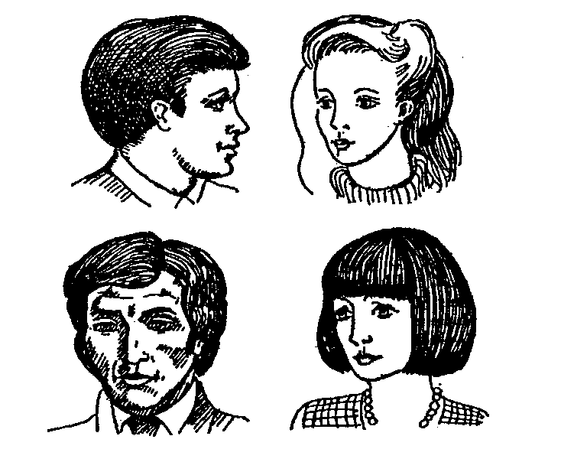
Let's look at this man. His name's Steve King. He's English. He's a lawyer in London. He's 30. He's very busy.
He isn't very happy
My name's Jane Snow. I'm an American. I'm 25. And I'm a teacher at the college in New York. A teacher's life isn't easy!

